W5 PRACTICE
STATEFULL WIDGETS

 Learning objectives
- create Stateful widgets
- be able to choose the right states and their type
- Render color or text labels depending on a state
- Use expanded widget, elevated buttons, SizeBox, image, buttons
- Manage a mix of stateless and stateful widgets

 No AI tools allowed to solve this practice

How to submit?
- Push your final code on your GitHub repository
- Then attach the GitHub path to the MS Team assignment and turn it in

 Before practice, to be prepared!
Read the following documentation to be ready for this practice:

https://www.classcentral.com/classroom/youtube-flutter-tutorial-for-beginners-45851/60c82bddaba3e
https://www.classcentral.com/classroom/youtube-flutter-tutorial-for-beginners-45851/60c82bddaba15
https://www.youtube.com/watch?v=GPoRjSjd1cI
https://api.flutter.dev/flutter/material/Card-class.html
https://www.classcentral.com/classroom/youtube-flutter-tutorial-for-beginners-45851/60c82bddaba0a
https://api.flutter.dev/flutter/widgets/Image-class.html

EX 1 – The selectable button
In this exercise, you need to create a Stateful widget to manage the selection of a button.

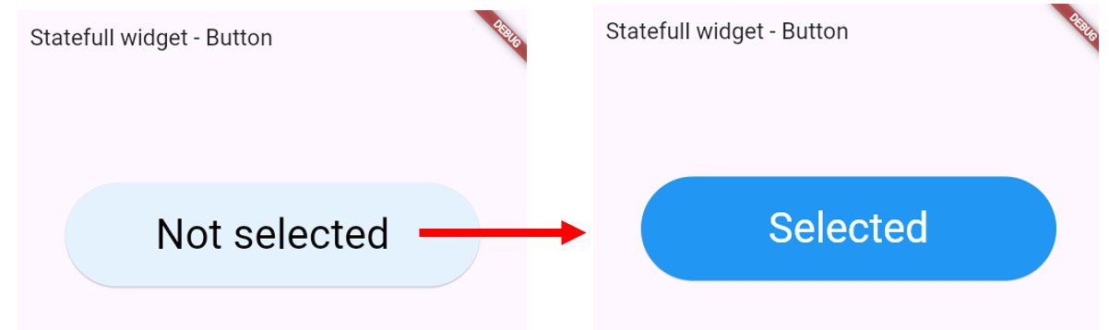
When clicked, the background button color and the text color should change

PART 1 – Understand the start code
Look at the start code and understand the different widgets and properties:

Center(
child: SizedBox(
width: 400,
height: 100,
child: ElevatedButton(
onPressed: () => {},
child: const Center(
child: Text("Not Selected"),
)),
),
)

- What is the goal of the SizeBox here? More information
- What is an ElevatedButton? More information

PART 2 – Create a stateful widget
Create a stateful widget containing the SizeBox and its children.

- Manage the selected condition
- Create getters to get the text, text color and background color depending on the state:

Status | Text label | Text color | Background color
selected | Selected | White | blue[500]
Not selected |  | Black | blue[50]

- Change the state value upon button click (reverse the selection)

TIP: to change the button background, you might need to use ElevatedButton.styleFrom

PART 3 – Try with different buttons!
- Create a column in the main () to manage different buttons
- Check that each manage manages its own selected state

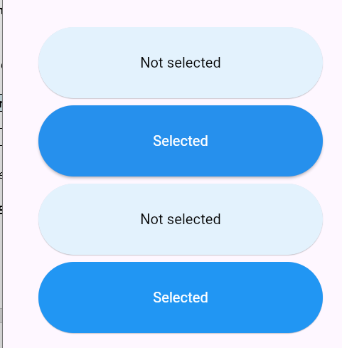
Each button should manage its own state

EX 2 – The best cards
In this exercise, you need to create a Stateful widget to manage a list of favorite cards.

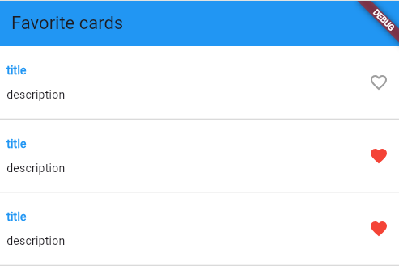

PART 1 – Layout the card
Important: For this first step, we provide the correction, but try to do it first by yourself!

Create the layout for following mockup:

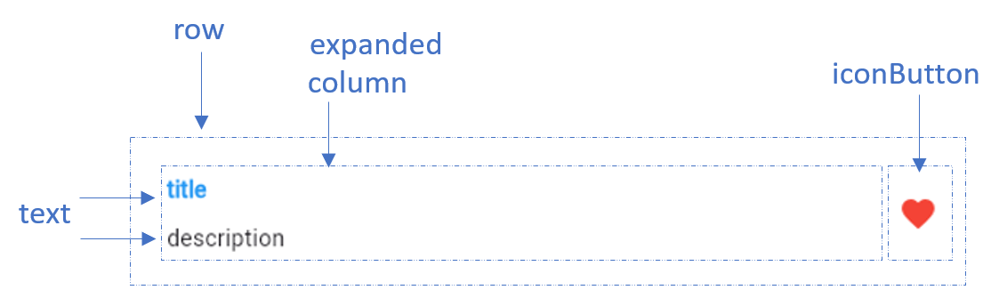

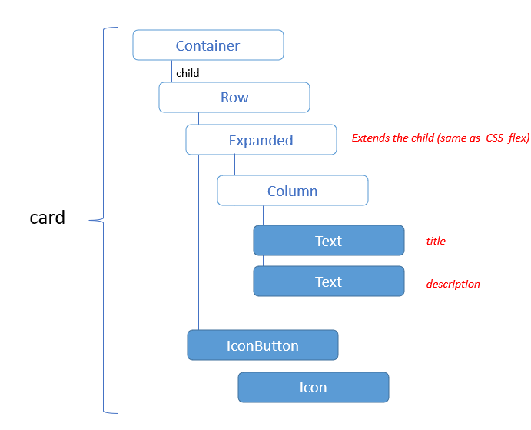

- You need to use the expanded widget to spread the column. More information
- You need to use the IconButton to display the heard in red. More information
- We also need a border at the bottom of the card: use Border and Border Side

PART 2 – Create a stateless widget
The second step is to create a stateless widget to manage many cards.
The widget takes are parameter the isFavorite value.

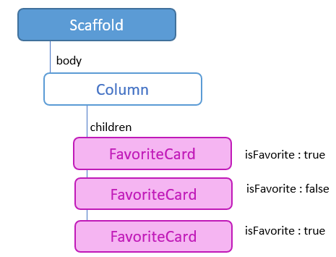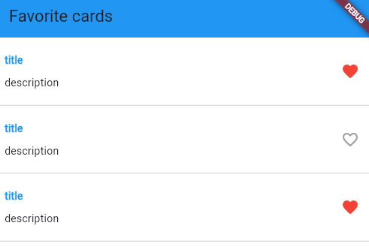

Example of usage of the Favorite card

PART 3 – Refactor to stateful widget
Now we want to change the favorite status when we click on each icon

It’s time to refactor the stateless widget to a stateful widget to manage the favorite status
- When we click on the heart icon, the favorite status shall change

Important: each FavoriteCard manage its own state (is favorite)

EX 3 – The Image Gallery (BONUS)
In this exercise, we want to create an image Gallery as follows:

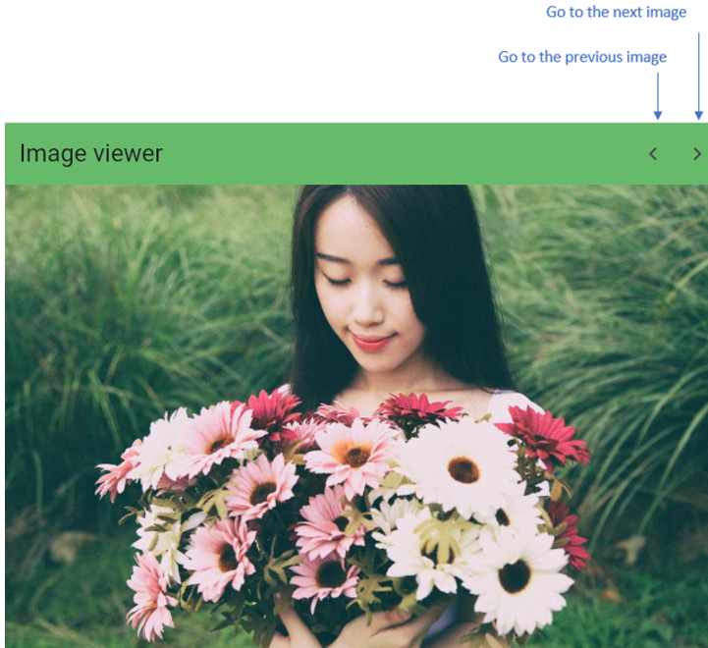

Note:
- For this exercise you have the start code with an empty app bar and the first image displayed
- Also copy the w4-s2/ images folder into your assets and update your pubspec.yaml

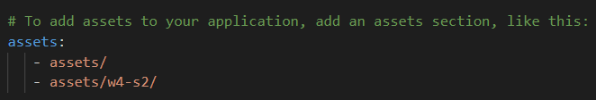

PART 1 – Add the previous and next button on App bar
- Add 2 buttons as bellow.
- Add 2 function to handle the clicks on the 2 buttons

Note: We needed to HIDE the little DEBUG banner, with this line on MaterialApp :
debugShowCheckedModeBanner: false,

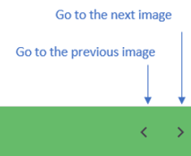

PART 2 – Manage the image state with a stateful widget

To manage the image gallery, with need a state and a stateful widget to handle which image is currently displayed.

Q1 – What type of state do you need to keep?

Q2 – Look at the current widget tree: which widget will you warp into your stateful widget?

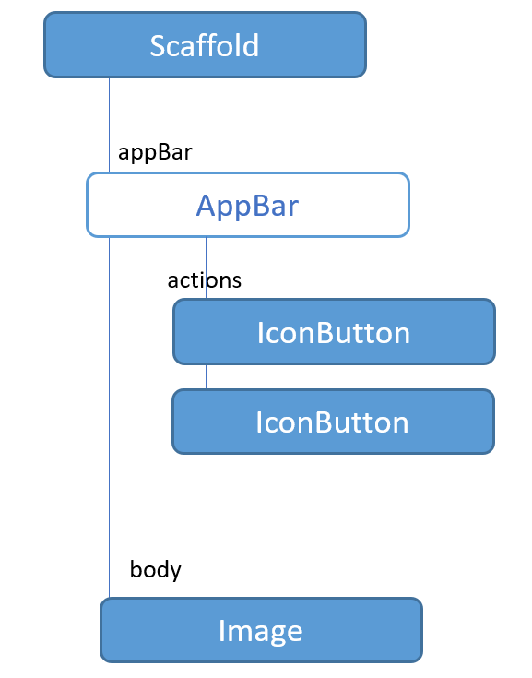

Important:
- It should be a circular carrousel: the previous of the first image is the last image, and the next of the last is the first... How can you manage this?

